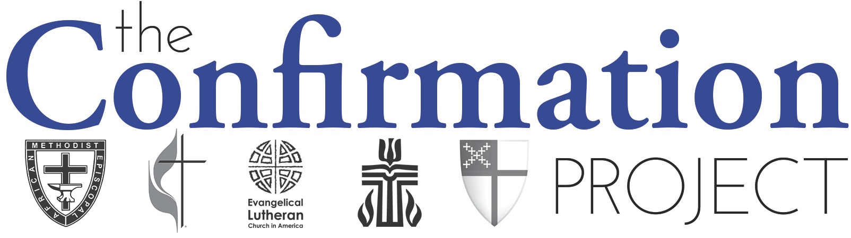

1. Qualitative Themes
- Resilient
- Contextual and owned by congregation
- Adaptive and responsive
- Committed leadership and resources
- High parental investment
- Bridge, not graduation

- Practices
- Building on congregation’s strengths
- Tending relationships
- Mentoring
- Exploring beliefs
- Making public affirmation of faith

- Three Hopeful Shifts
- Purpose
Engagement first, doctrine second.
- Shift from focus on rite to focus on youth engagement
- Adaptive practice meeting spiritual hunger
Lifelong followers of Jesus first, Christian community second.
- Shift from focus on equipping for church membership and denominational loyalty to lifelong journeys as followers of Jesus
- Personal faith as part of a larger tradition and connected to Christian community
Confirmation as an intensive, focused time of learning the practices and beliefs of the Christian faith.
Question - How is confirmation meeting the spiritual hungers of youth AND teaching the beliefs and practices of the church?

- Pedagogy
Freedom & Accountability
- Shift from traditional, didactic instruction to resource-rich learning environment
- Draws on the agency of students, invites them into teaching and learning process
Life-wide, relationally-rich
- Shift from cognitive learning about Christianity to active engagement with it
- Intentionally designed to connect personal life, faith, and world
Confirmation as transformational learning and vocational discernment
Question - In what ways is confirmation ministry drawing youth into a vibrant learning community?

- Context
Local & Organic
- Shift from uniform practice to working with congregational and contextual assets and challenges
- Ongoing discernment and attention to congregational and contextual needs
Congregation-wide
- Shift from separate ministry/event to process owned by congregations and connected to the wider church/community
- Shared leadership and ownership of confirmation
Confirmation as adaptive and resilient faith formation ministry
Question - How is confirmation ministry taking into account the particularities of your setting?

- Lived Tensions
- Accommodation – “Orthodox” doctrine
- Gospel as status quo – Gospel as disruption
- Quick and easy – Slower and deeper
- Need mentors – Spiritual maturity of mentors
- Focus on confirmation – What’s next?

- Re-imagining Confirmation
- It matters
- It takes a team
- Builds intergenerational learning community
- Claiming the Way of Jesus
- Practitioners need to talk with each other

