Portraits – Small Town, Small, Collingswood, New Jersey
Experiential Learning

CONTEXT

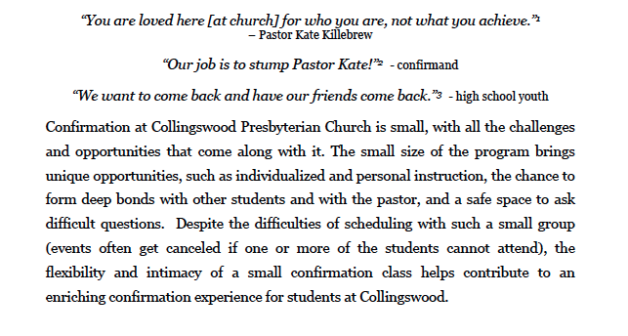
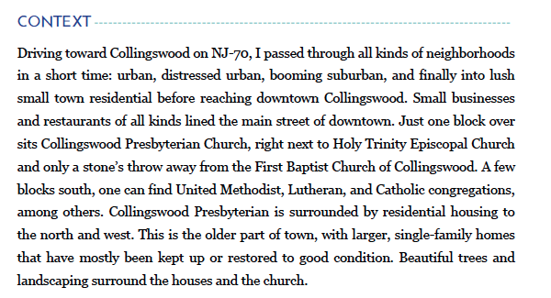
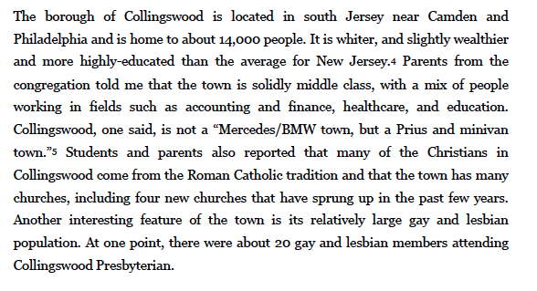
What strikes you so far? What questions do you have?

CONGREGATION
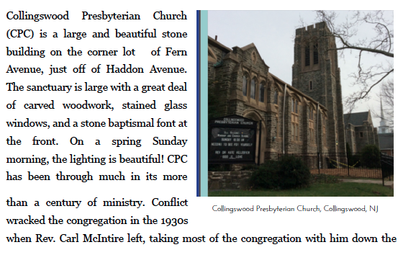
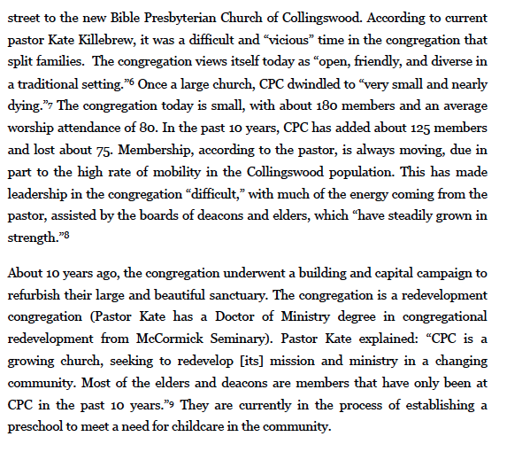
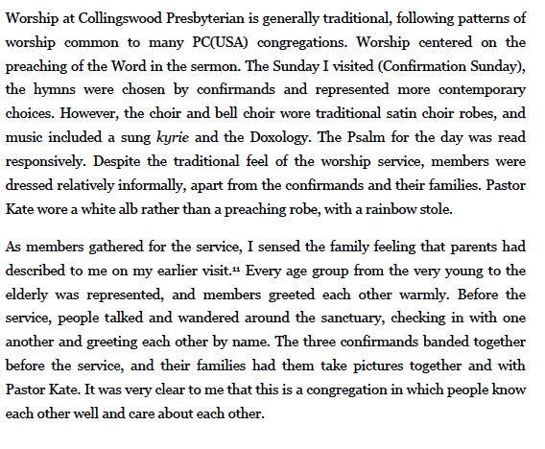
What would you see as critical elements of confirmation ministry in this setting? What would be the challenges?

CONFIRMATION

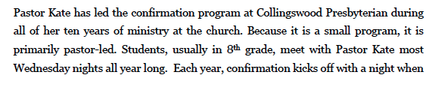
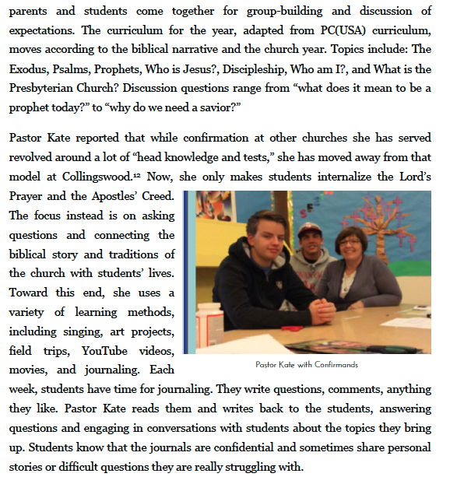
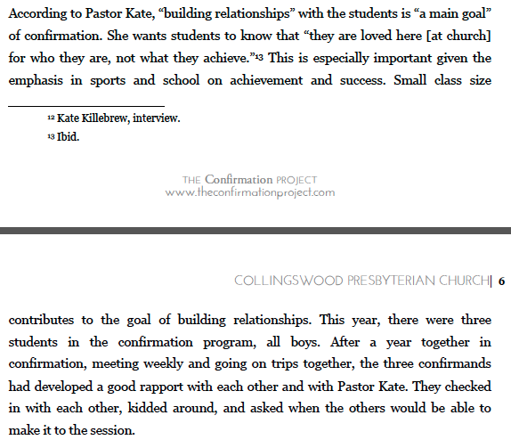
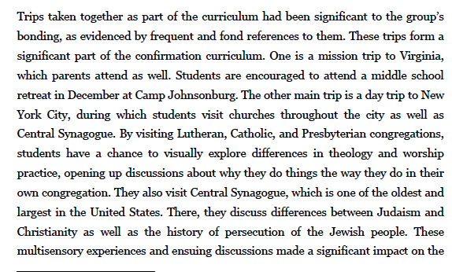
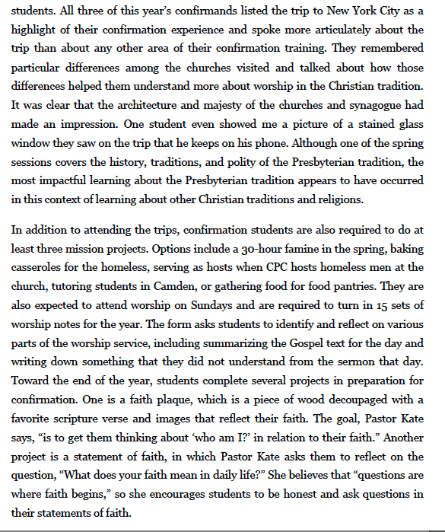
What is interesting to you about this approach to learning? What might this approach look like in your setting? What would your goals be?

How do these activities support and/or complement the other types of learning? How do these approaches to learning take into account the developmental realities of these students?
How might such an approach be modified for other settings?
What is a lesson you are taking away from this context?

